- Create one IAM user and assign EC2 and S3 full access roles.
- You can type IAM in your search tab and in that on the left side you can see user under Aws identity and access management
- • On the left panel → click Users
• Click Create user
• Enter username (example: asim-user)
• Click Next
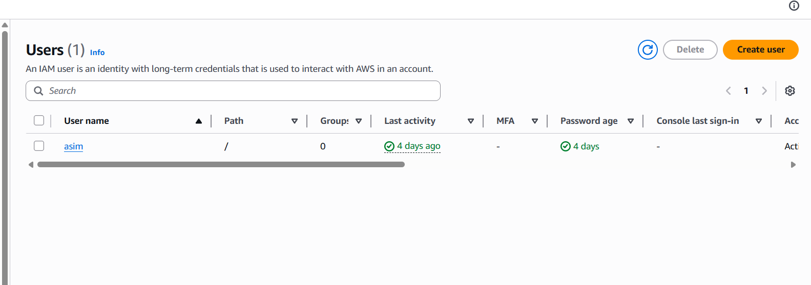

- Choose: Attach policies directly
- In search bar, type and select:
- AmazonEC2FullAccess
- AmazonS3FullAccess
👉 These are AWS managed policies (pre-made permissions)
- Click Next
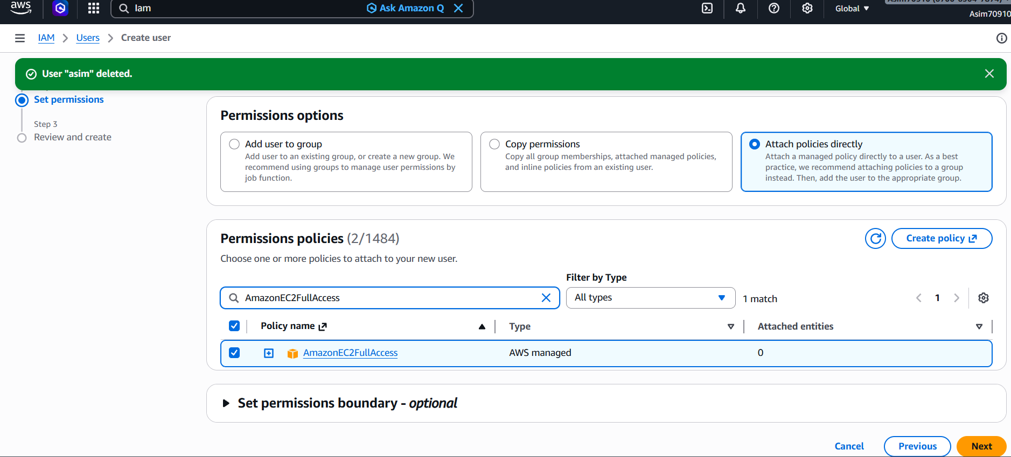

User created
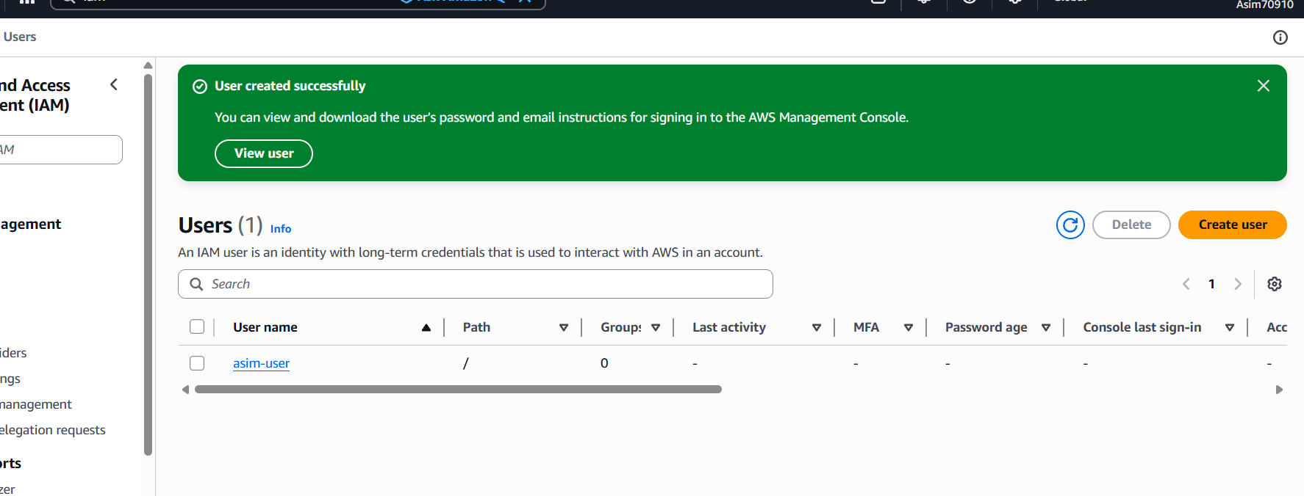

🔹 Step 6: Create Login Access (Important)
If you want to login with this user:
- Click on the created user name
- Go to Security credentials
- Click Create access key (for CLI) OR
Go to Console access → Enable password
- Set password → Save
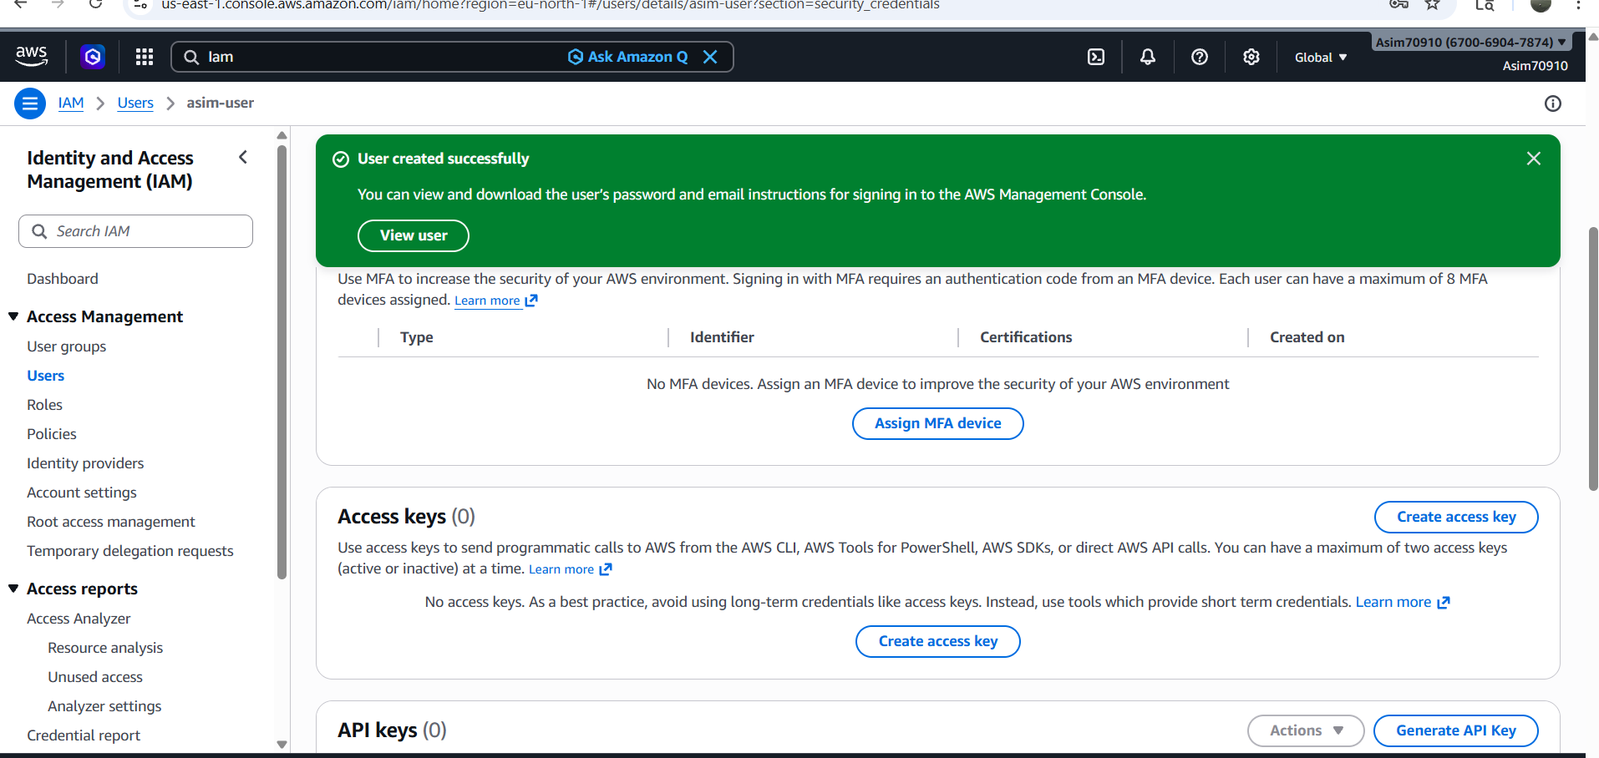

- I did not enable - ✔️ “Provide user access to the AWS Management Console”
🔹 Step 3: Enable Console Login
- Inside the user page:
- Go to tab: Security credentials
- Scroll to section: Console sign-in
- 👉 You will see one of these:
- If console access is NOT enabled:
- It will show “Enable console access” button
- Click it.

- 🔹 Step 4: Set password
- You will get options:
- Autogenerated password OR
- Custom password (choose this 👍)
- Set a password and confirm
- Then click:
👉 Save changes / Enable

- 🔹 Step 5: Give login details
- Now you can log in using:
- Username: your IAM user name
- Password: the one you set
- Login URL: IAM sign-in link
- Downloaded the key
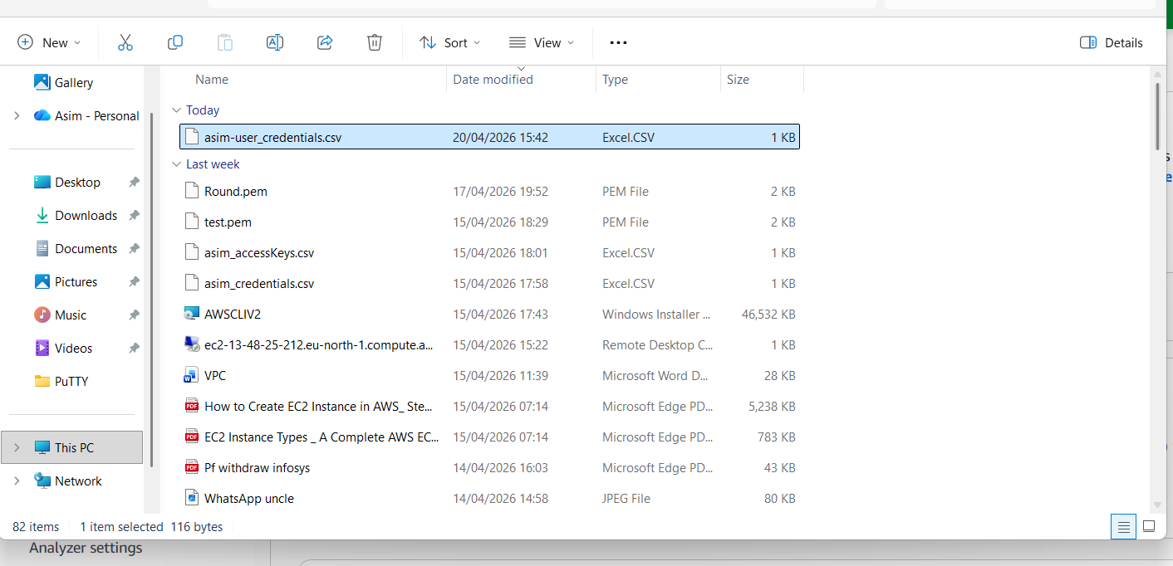

2nd task - Create one group in IAM and assign read access for EC2.

You need to login to aws console with the
URL - https://YOUR-ACCOUNT-ID.signin.aws.amazon.com/console

https:// 670069047874.signin.aws.amazon.com/console

You will be able to see an interface -
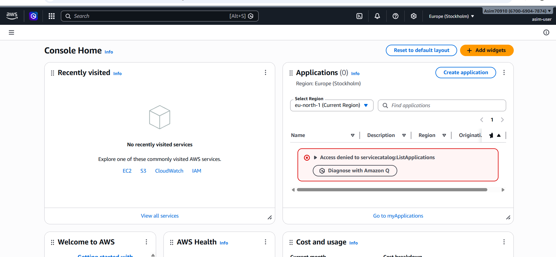

Done with 1st task

- Create one group in IAM and assign read access for EC2.

  - You have to go to IAM and go to user groups and create user group
. Add name
. Add IAM user if not you need to create a new one
. Attach Policy for EC2 Read Access ( AmazonEC2ReadOnlyAccess )
. Click Create group
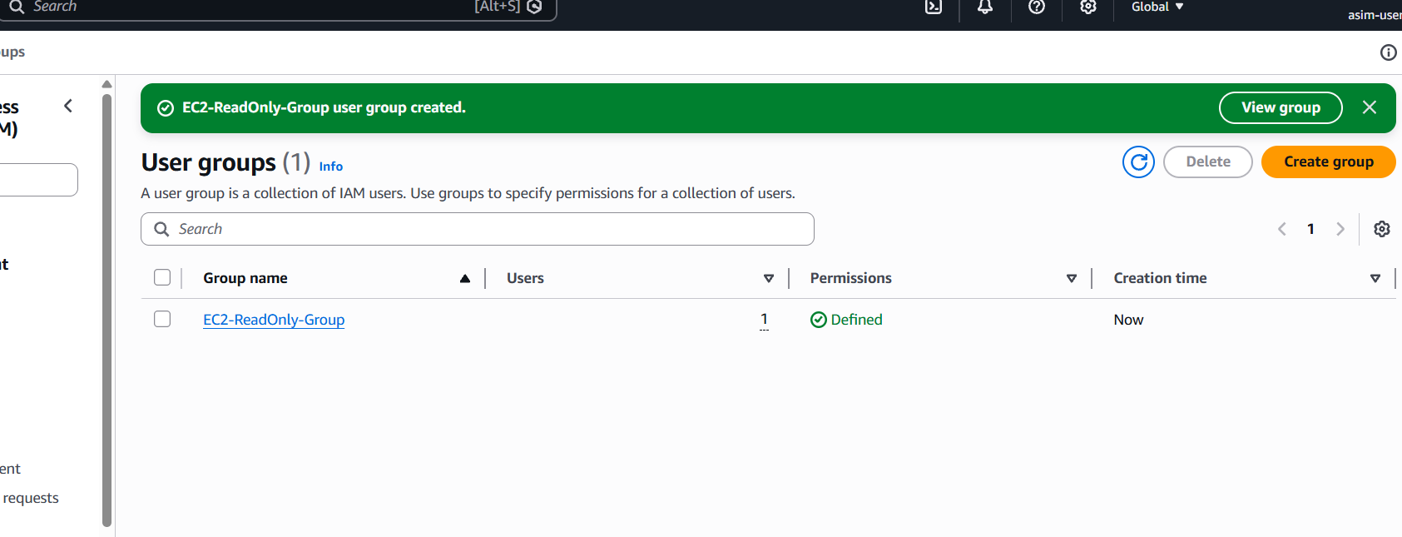
✅ What to do next
1. Click Create user (orange button)

2. Enter details
- Username:
Devops

3. Select access type
- ✅ Check Provide user access to the AWS Management Console
- Set password (auto or custom)

4. Permissions step
- Choose: Add user to group
- Select your group (the one you created earlier, e.g. EC2 read-only group)
That group should already have:
- AmazonEC2ReadOnlyAccess

5. Finish
- Click Next → Create user

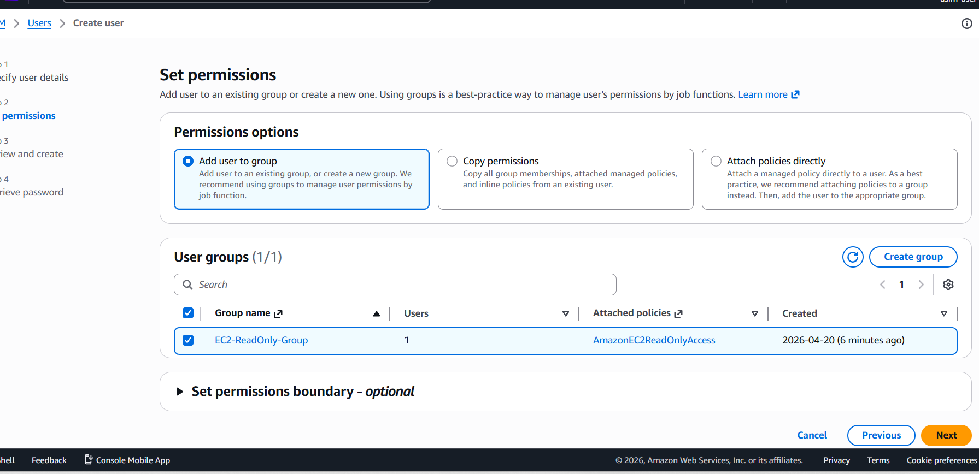

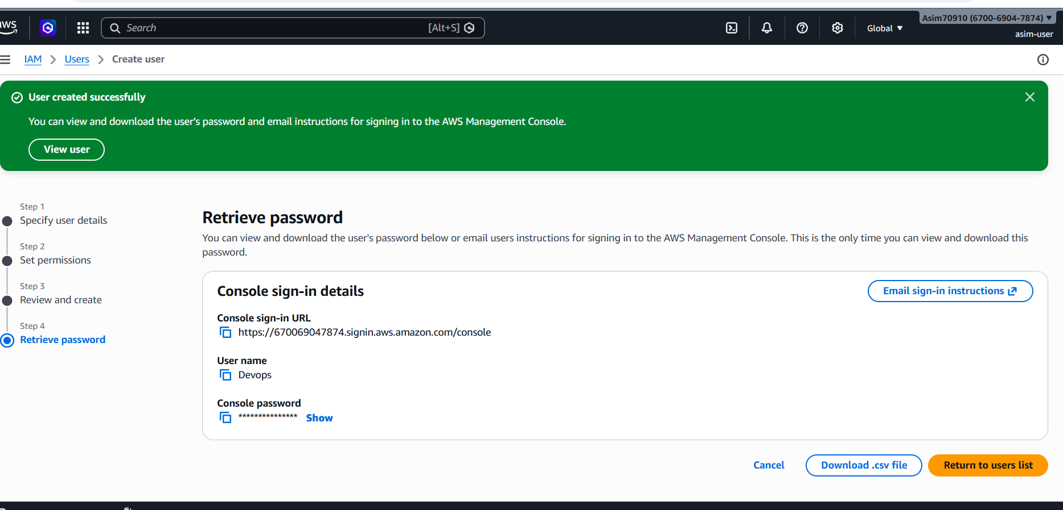
Done with second task
4th . Write a bash script to create an IAM user with VPC full access.
steps you need to do first you need to create and edit a file
1. vi test-01.sh and
2. paste the bash script
3. need to add permission - chmod +x test-01.sh
4. test the key - ./test-01.sh (it will throw an error)
- aws configure
You need:
- Access Key
- Secret Key
- Region

Down you can see access key and secret key

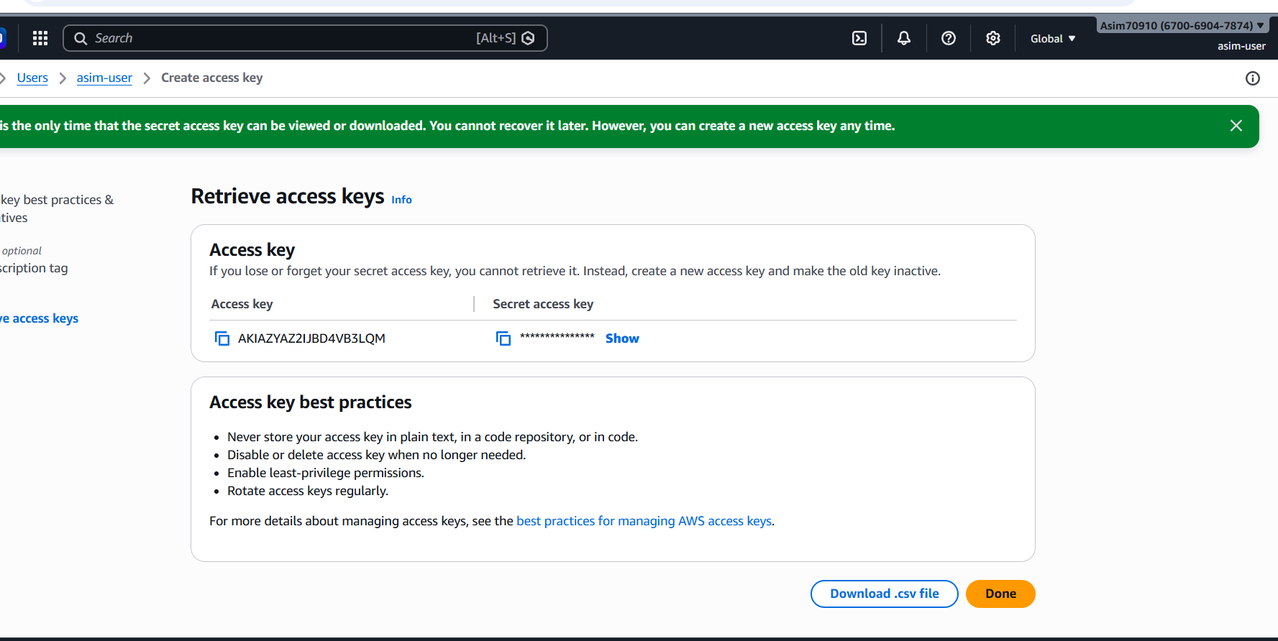

5th task - 5. Create an IAM policy to allow EC2 access for a specific user in specific regions only.

- Go to AWS Console
- Search → IAM
- Click Policies
- Click Create policy

step – 2
Click JSON tab and paste this:
{
"Version": "2012-10-17",
"Statement": [
{
"Sid": "EC2AccessSpecificRegions",
"Effect": "Allow",
"Action": "ec2:*",
"Resource": "*",
"Condition": {
"StringEquals": {
"aws:RequestedRegion": [
"ap-south-1",
"us-east-1"
]
}
}
}
]
}
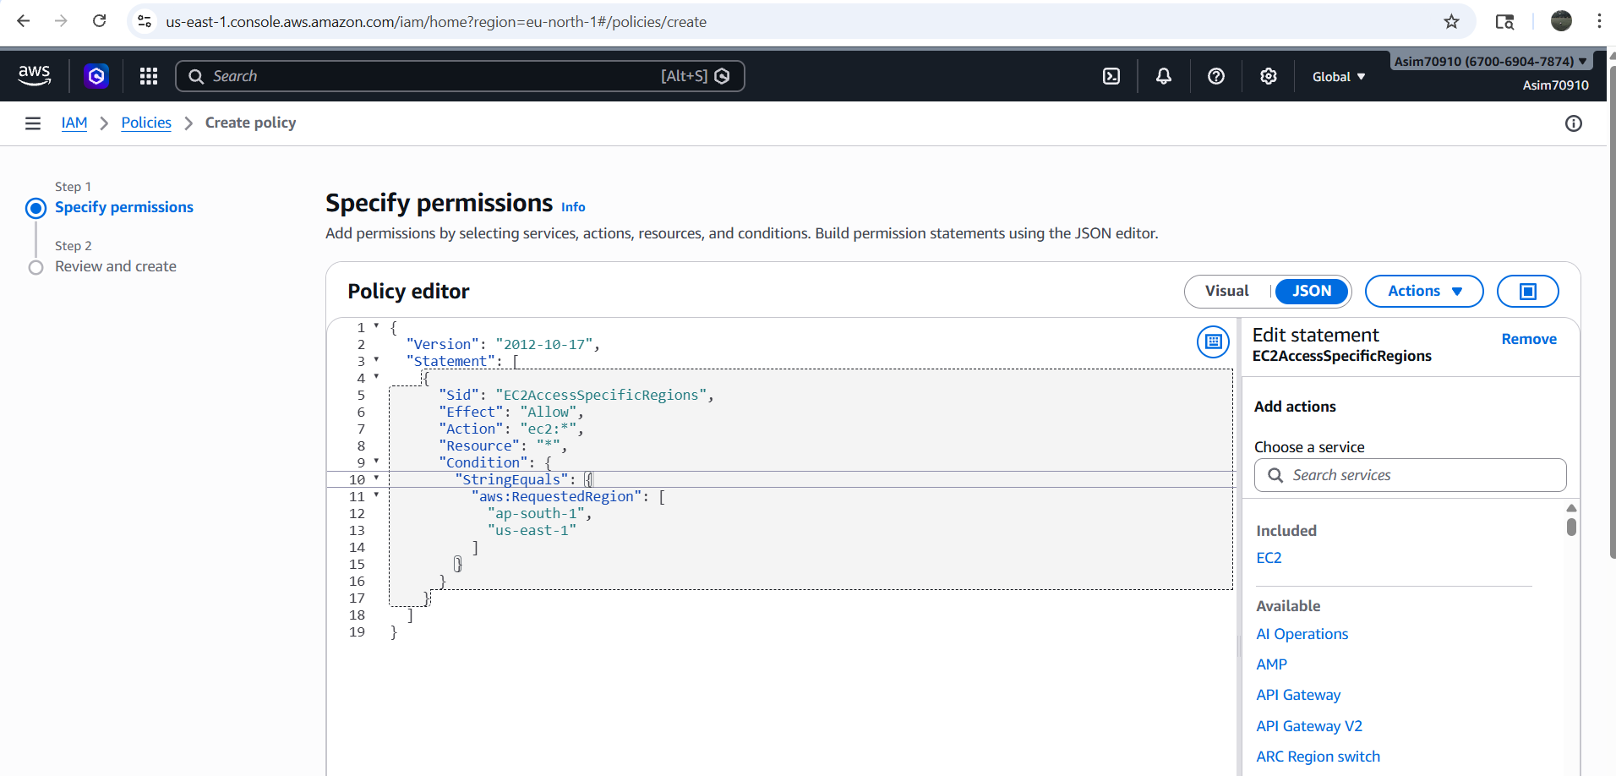

Click next and add give a name ex - EC2-Region-Restricted-Policy

Step 4: Attach Policy to User
- Go to IAM → Users
- Select your user (e.g., Devops)
- Go to Permissions tab
- Click Add permissions
- Choose:
👉 Attach policies directly
- Select:
👉 EC2-Region-Restricted-Policy
- Click Next → Add permissions

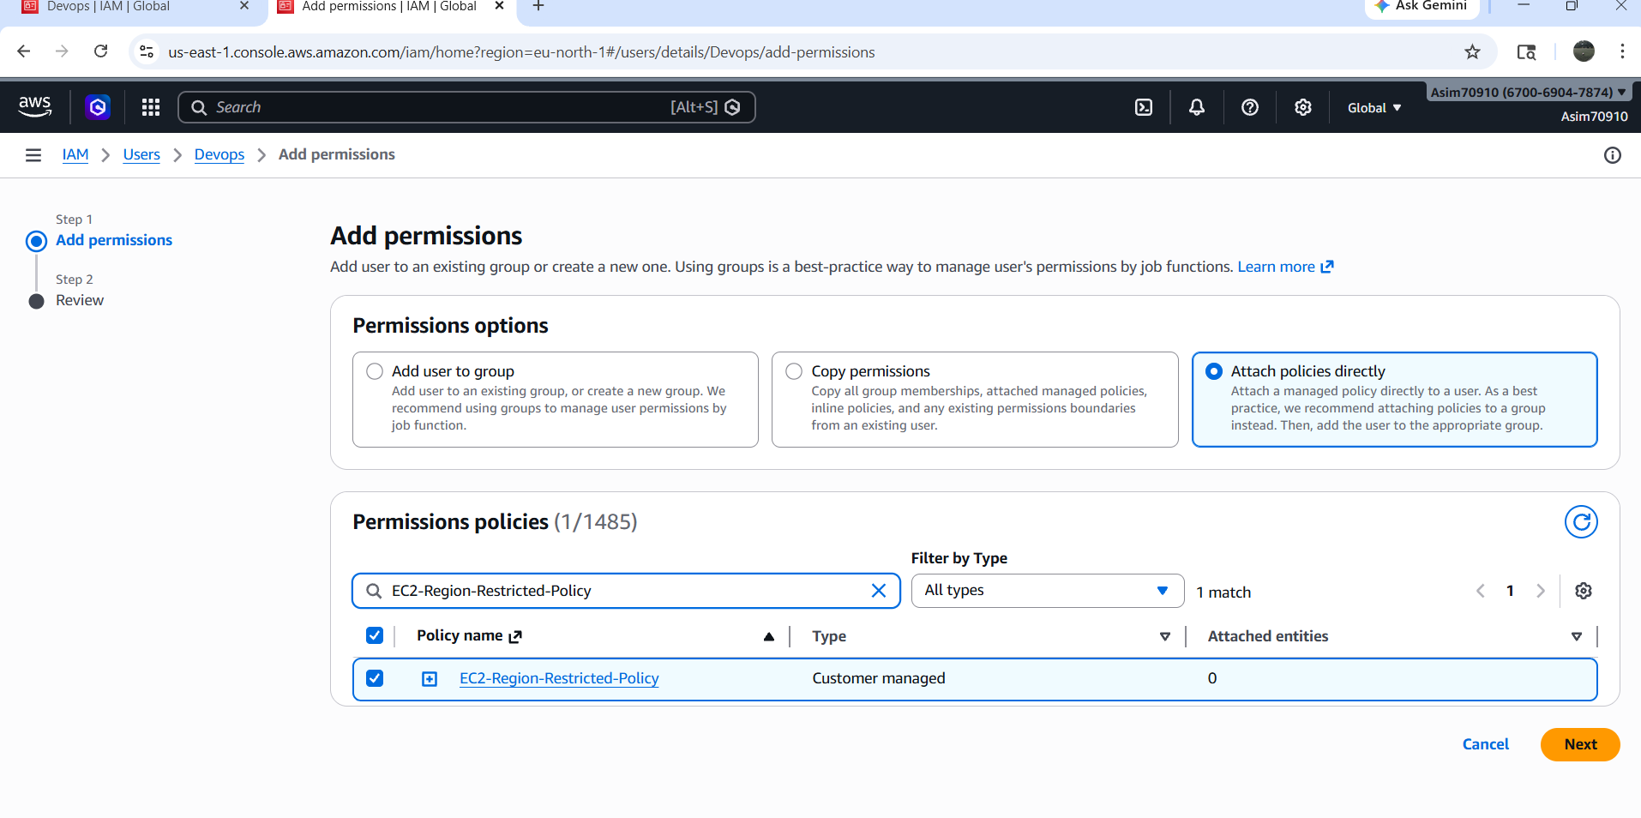

Logged in AWS console page as AMI user (Devops) password (******) and was able to create a instance in ap -south-mumbai region
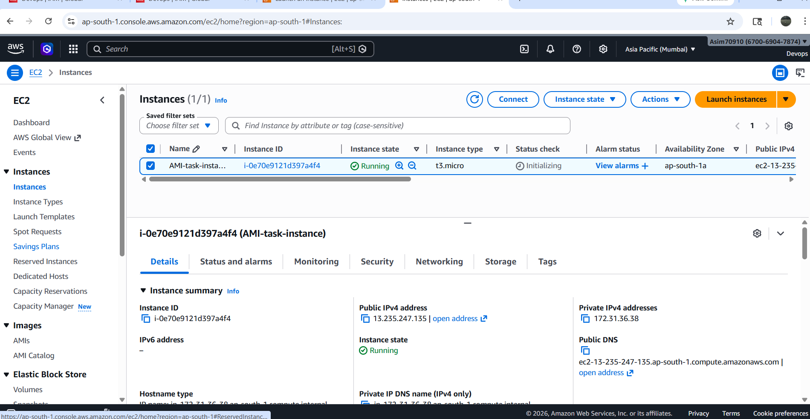

6th task is pending as there is no one to collaborate as team

